What is an outdoor classroom?
An outdoor classroom is an outdoor educational space that brings learning to life by bringing learning outside. It becomes a gathering place for teachers and students and provides an opportunity to integrate nature into your school grounds. All subjects or curriculum can be presented in an outdoor classroom and can be used in every season. To get started, you need a great plan and plenty of school commitment. Elements of an outdoor classroom can include:
- Natural features (trees, fields, wetlands) - Greenhouses
- Trails - Outdoor chalkboard and seating
- Gardens (vegetable, butterfly) - Study space
- Creative space - Fitness and balance elements
Grants are available for early learning centers through grade 12 schools to build an outdoor classroom at their site. Funding is provided through Friends of Acadia to support more youth engagement with Acadia National Park. Outdoor classrooms must be on school grounds and provide a curriculum link to Acadia.

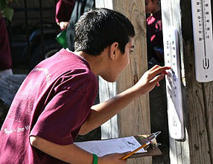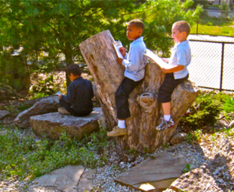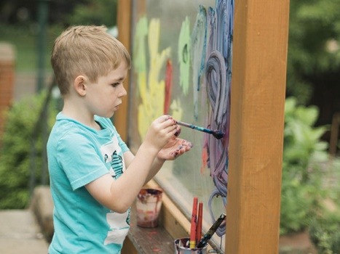
Images: The Outdoor Classroom Project, Boston Schoolyard Initiative, & Nature Explore

Grant Funding
Total funds available per school over a 5-year period: $20,000.
- $10,000 for grant implementation.
- $5,000 for staff training: $1,000 per school year.
- $5,000 for optional field trips to Acadia and/or ranger school visits: $1,000 per school year.

Grant Requirements
- Complete Application Materials – Applications are accepted on a rolling basis.
- Letter of Administrative Support
- Outdoor Classroom Objectives and Timeline
- Outdoor Classroom Fund Request
- Map of Design Plan, if applicable
- Estimated Number of Participants
- Contact Information
- Attend Professional Development – Grant recipients will receive an additional $1,000 in staff training funds per school for each year of the grant. Staff will participate in training tailored to the content and site of your outdoor classroom project, which will be decided upon by school staff. Professional development examples: Project WILD/WET, Nature Explore, ANP Park Rangers, etc.
- Link Curriculum to Acadia National Park - Students must study three lessons throughout the school year, using the outdoor classroom, which link to current issues in Acadia: natural processes, cultural history, environmental issues, arts in the park, etc.
- Provide Documentation of Use - Grant reports are due July 1st for each year of grant activity. Please provide documentation that students are participating in outdoor learning 18 days of the school year (~ 10%) through photos, written summaries of student and teacher experiences, etc. Documentation should showcase the Acadia-linked lessons that the students have studied.
- Optional Field Trip and/or Ranger Visit – Grant recipients will receive an additional $1,000 in transportation funds per school for each year of the grant to attend an optional field trip to Acadia National Park, after using the outdoor classroom and learning about the park. Transportation funds may also be used to bring park rangers to campus more than once, depending upon staff availability.
Please fill out the following sections or attach to the application:

Curriculum Goals
Please share your curriculum goals for creating or improving an outdoor classroom.
____________________________________________________________________________________________________________________________________________________________
Outdoor Classroom Objectives and Timeline
Objectives | Timeline
- Design Plan
- Construction
- Landscape Materials
- Educational Resources
- Initial Staff Training
- Student Use of Outdoor Classroom
- Site Maintenance
- Long-term Staff Support

Estimated Outdoor Classroom Fund Request
Funds are available up to $5,000 per year for a total of $10,000 over a 5-year period. Funds can be used for the expense categories listed on page 4. More funds may be given when more students participate.
Any other funding sources? ______________________________________________________________

Estimated Number of Participants
# Students ______________ # Adults (Staff, Parents) _____________ # TOTAL ____________

Expense | Description | Cost
- Design Plan (including site consultation if needed)
- Construction
- Landscaping Materials
- Educational Resources
Additional Comments: |  | Total Cost:

Contact Information
School Name: _________________________________________________________________________
School District: ________________________________________________________________________
Teacher(s): ___________________________________________________________________________
Grade Level(s): ________________________________________________________________________
Phone: ______________________________________________________________________________
Email(s): _____________________________________________________________________________
Mailing Address: _______________________________________________________________________
School Official’s Signature: _______________________________________________________________
If approved, to whom and where should the check be sent to? _________________________________
_____________________________________________________________________________________
Please submit applications and questions to:
Paige Steele, conservation projects manager at Friends of Acadia.
Email: paige@friendsofacadia.org
Phone: (207) 288-3340, Fax: (207) 288-8938
Address: PO Box 45, Bar Harbor, Maine 04609

