Enhance Outdoor Classroom Grants
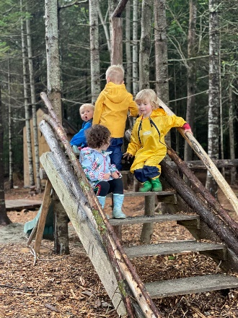
Grant supports campuses who have received a previous outdoor classroom grant from Friends of Acadia to expand outdoor learning. The grant is designed to be flexible to meet your community needs and reduce barriers for staff and students to enjoy learning outdoors.

Enhance grant funds may be used for the ideas below and much more:
- Outdoor classrooms with chalkboard and seating.
- Greenhouses and gardens (butterfly and veggie).
- Multi-purpose trails for walking, biking, and more.
- Water-quality kits, binoculars, backpacks, field guides, etc.
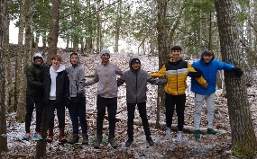
- Gear for students and staff like snow pants, mittens, boots.
- Creative, study, and/or emotional regulation spaces.
- Ropes course, archery, boats, PFD’s, fishing gear, bikes, etc.
- Snowshoes, sleds, ice fishing gear, ski equipment, etc.
- Adaptive wheelchairs and ramps for chairs.
- Natural play areas like mud kitchens and play logs.
Use your imagination, and better yet, use your students’ imagination!
Grant Amount
- Grants of $500 – 1,500 each are available for returning outdoor classroom grant recipients.
- Grants are awarded first come, first serve Jan 1st – Dec 1st to campuses in Hancock, Penobscot, and Washington counties.
- Grant fund amounts for 2026 are based on the number of students for the campus (not district) you plan to serve. Refer to the scale below:
Number of Students Award Amount
0 - 49 | $500
50 - 149 | $1,000
150 + | $1,500

Grants available per school campus (not per school district)
- School/YMCA campuses must have received an Outdoor Classroom grant from Friends of Acadia. Campuses must be located in Hancock, Penobscot, and Washington counties in the State of Maine.
- If using funds to build structures, trails, gardens, and such then the feature must be built on the school or YMCA campus. The outdoor learning space should be within walking distance of the building(s) and not require transportation, except in mobility cases. The property that the feature is built on must be owned by the school, YMCA, Tribe, and/or town in the case of a public school.
- YMCA Early Learning Centers serving infants through afterschool care must be Licensed by the State of Maine and serving early childhood youth full-time.
- Curriculum link to Acadia National Park: Students must study three lessons throughout the school year which connects to Acadia: natural and cultural history, arts in the park, wildlife etc.
- Grant reports are due December 1st, one year following your grant award. Provide documentation that students are learning outdoors ~18 school days (10%) through photos, written summaries of student and teacher experiences, Acadia-linked lessons, etc.

Grant Requirements

Required Application Materials
- Estimated number of participants, students and staff.
- Amount of funds being requested.
- Outdoor Classroom plan and design map, if applicable.
- Examples of lessons connecting students to Acadia National Park.
- State of Maine childcare license for YMCA sites.
- Signature of administrative support and contact information.

- Estimated Number of Participants: Student # _____ Adult # (Staff, Parents) _____ TOTAL # _____

- Provide the requested grant amount: __________________________________________________

- Describe your outdoor classroom grant plans including student use and timeline:
_____________________________________________________________________________________
_____________________________________________________________________________________
_____________________________________________________________________________________
_____________________________________________________________________________________
_____________________________________________________________________________________

- ANP Lessons - Please share examples of how your students will connect to Acadia NP via 3 lessons:

_______________________________________________________________________________________________________________________________________________________________________________________________________________________________________________________________
_____________________________________________________________________________________
- State of Maine childcare license number (for YMCA) ______________________________________

- Administrative Signature & Contact Information
School Official’s Signature: _______________________________________________________________
School Name & District: _________________________________________________________________
Staff Submitting Application:______________________________________________________________
Grade Levels (check all that apply): Infant thru Pre-K ____ K-2 ____ 2-5____ 6-8____ 9-12____
Phone Number with area code:___________________________________________________________
Email(s): ____________________________________________________________________________
Mailing address for grant check to be sent:
Name of School ___________________________________________________________
Name of Recipient ___________________________________________________________
Street Address or P.O. Box ___________________________________________________________
City, State, Zip ___________________________________________________________
Please submit applications and questions to: For Acadia National Park field trip inquiries:
Paige Steele, Acadia for All Director Kate Petrie, Education Coordinator
Friends of Acadia Acadia National Park
Email: paige@friendsofacadia.org Email: kate_petrie@nps.gov
Phone: (207) 370-7995 Phone: (207) 288-8812
Fax: (207) 288-8938
Mailing Address:
Friends of Acadia
C/O Paige Steele
P.O. Box 45
Bar Harbor, Maine 04609

