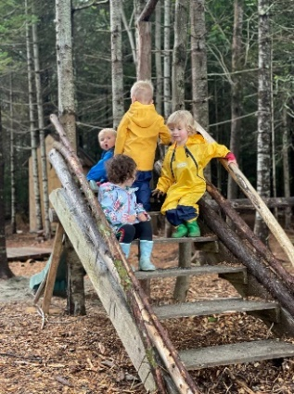
What is an outdoor classroom?
An outdoor classroom is an educational space on your school grounds that provides an opportunity to learn, recreate, and restore outside. These spaces engage all the senses while learning, which improves academic outcomes of students, as well as increases stewardship values and the well-being of all who use the space. Outdoor classrooms can be an all-season gathering place for schools. To get started, you need a great plan and the support of your school community. Outdoor classroom grant funds may be used for the ideas below and much more:
- Outdoor classrooms with chalkboard and seating.
- Greenhouses and gardens (butterfly and veggie).
- Multi-purpose trails for walking, biking, and more.
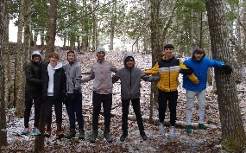
- Water-quality kits, binoculars, backpacks, field guides, etc.
- Gear for students and staff like snow pants, mittens, boots.
- Creative, study, and/or emotional regulation spaces.
- Ropes course, archery, boats, PFD’s, fishing gear, bikes, etc.
- Snowshoes, sleds, ice fishing gear, ski equipment, etc.
- Adaptive wheelchairs and ramps for chairs.
- Natural play areas like mud kitchens and play logs.
Use your imagination, and better yet, use your students’ imagination!

Grant Funds
Funding supports more youth engagement with Acadia National Park. The grant is designed to be flexible to meet your community needs and reduce barriers to outdoor learning. Funds may be used to create a new outdoor learning space or enhance an existing space. Funds may also be used to purchase educational supplies, outdoor gear, and much more.

Grants available per school campus (not per school district)
- Grants are available for public schools, Tribal schools, and YMCA early learning centers located in Hancock, Penobscot, and Washington counties in the State of Maine. Private high schools located in these counties who serve students via the school choice program are eligible to apply. If grant funds are still available by October 1st, remaining funds will be opened to all Maine public schools.
- Grants are awarded first come, first serve Jan 1st – Dec 1st . Grant fund amounts for 2026 are based on the number of students for the campus (not district) you plan to serve. Refer to the scale below:
Number of Students Award Amount
0-49 | $1,000
50-99 | $1,500
100-199 | $2,000
200-299 | $2,500
300 + | $3,000

- Enhance grants of $500 – 1,000 each are available for previous outdoor classroom grant recipients. Please find the 1-page application on the Friends of Acadia website to renew your grant funding.

Grant Requirements
- Campuses must be located in Hancock, Penobscot, and Washington counties in the State of Maine.
- All outdoor learning structures, such as pavilions and greenhouses, must be located on the public school or YMCA campus. The space should be within walking distance of the building(s) and not require transportation, except in mobility cases.
- YMCA Early Learning Centers serving infants through afterschool care must be Licensed by the State of Maine and serving early childhood youth full-time, year-round.
- Curriculum link to Acadia National Park: Students must study three lessons throughout the school year which connects to Acadia: natural and cultural history, arts in the park, wildlife, etc.
- Grant reports are due December 1st, one year following your grant award. Provide documentation that students are learning outdoors ~18 school days (10%) through photos, written summaries of student and teacher experiences, and Acadia-linked lessons.

Required Application Materials
- Estimated number of participants, students and staff.
- Amount of funds being requested.
- Outdoor Classroom plan and design map, if applicable.
- Examples of lessons connecting students to Acadia National Park.
- State of Maine childcare license for YMCA sites.
- Signature of administrative support and contact information.
- Estimated Number of Participants: Student # _____ Adult # (Staff, Parents) _____ TOTAL # _____
- Provide the requested grant amount: __________________________________________________
- Describe your outdoor classroom grant plans including student use and timeline:
_____________________________________________________________________________________
_____________________________________________________________________________________
_____________________________________________________________________________________
_____________________________________________________________________________________
_____________________________________________________________________________________

- ANP Lessons - Please share examples of how your students will connect to Acadia NP via 3 lessons:

_______________________________________________________________________________________________________________________________________________________________________________________________________________________________________________________________
_____________________________________________________________________________________
_____________________________________________________________________________________
- State of Maine childcare license number (for YMCA) ______________________________________

- Administrative Signature & Contact Information
School Official’s Signature: _______________________________________________________________
School Name & District: _________________________________________________________________
Staff Submitting Application:______________________________________________________________
Grade Levels (check all that apply): Infant thru Pre-K ____ K-2 ____ 2-5____ 6-8____ 9-12____
Phone Number with area code:___________________________________________________________
Email(s): ____________________________________________________________________________
Mailing address for grant check to be sent:
Name of School ___________________________________________________________
Name of Recipient ___________________________________________________________
Street Address or P.O. Box ___________________________________________________________
City, State, Zip ___________________________________________________________
Please submit applications and questions to: For Acadia National Park field trip inquiries:
Paige Steele, Acadia for All Director Kate Petrie, Education Coordinator
Friends of Acadia Acadia National Park
Email: paige@friendsofacadia.org Email: kate_petrie@nps.gov
Phone: (207) 370-7995 Phone: (207) 288-8812
Fax: (207) 288-8938
Mailing Address:
Friends of Acadia
C/O Paige Steele
P.O. Box 45
Bar Harbor, Maine 04609

